**Cine Craft Management System**



**SAP ABAP MODULE POOL APPLICATION**

**BY**

**GROUP - 1**

Under the Guidance of: **Mr. Upender Reddy Nallori**

**Team Members**

**Divyangi Singh(1403634)**

**Debasmita Bhatta(1403669)**

**Rohan Chakroborty(1403680)**

**Trikash Guha(1403675)**

**Sayantan Mitra(1403677)**

**Introduction**

This application is designed to help movie makers to keep track of their project. Movie Makers can search for their crew members and post jobs in which people can apply. We are also providing the help section at individual level for women and other financial problem. We kept a separate finance section to keep track of payments.

**Use Case Diagram**

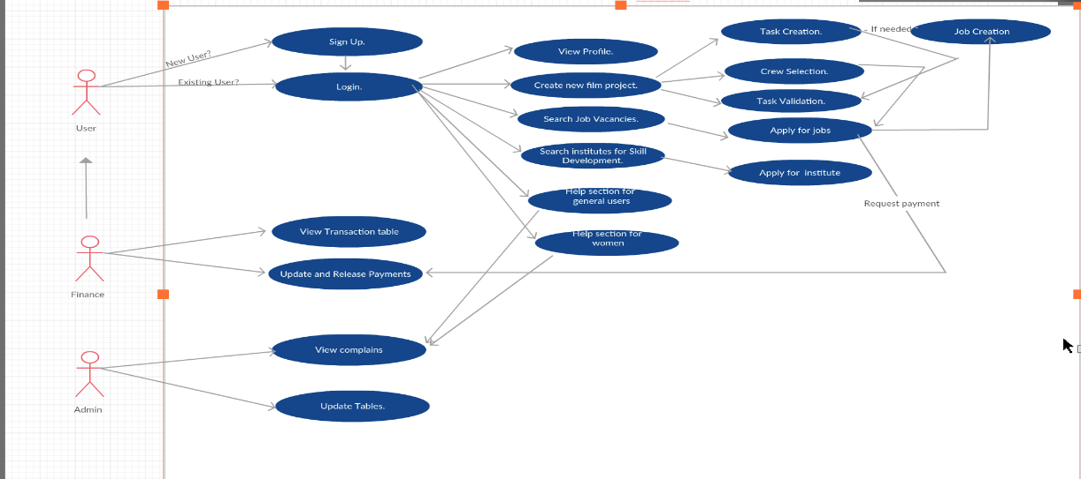

**Flow Chart**

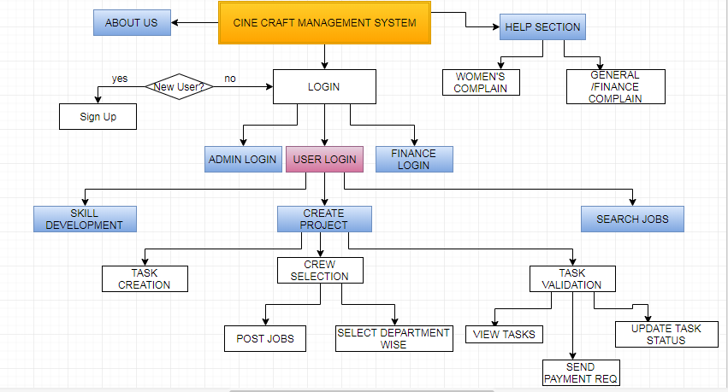

**List of Tables**

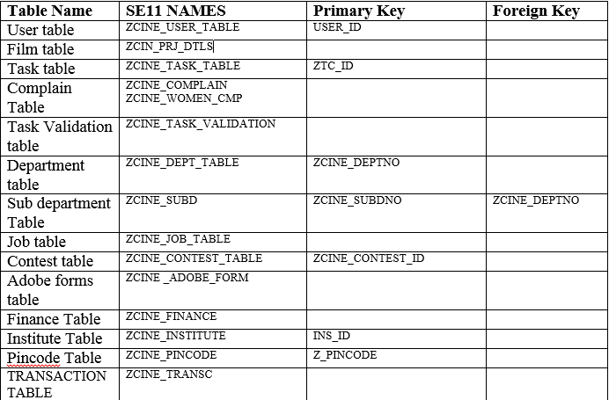

**List of Screens**

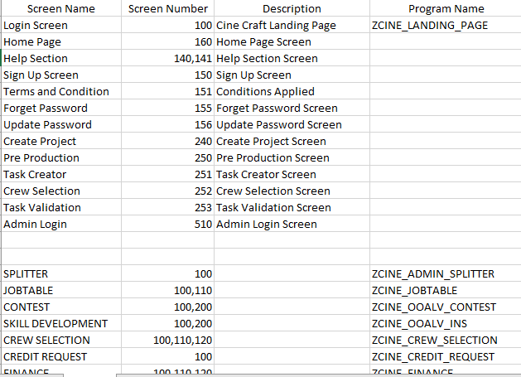

**Methodology**

**Phase I**

**Research and Information/Requirement Gathering**

* Understanding the basic procedures involved in film making
* Figuring out the target users
* Figuring out use cases

**Result**

* **The step involved in movie making**

**(Source of info:www.cd-writer.com/10steps.html#step3)**

* + Film concept or idea formation
  + Finding/writing/finalizing script
  + Drawing story boards for your film
  + Funding your film
  + Find cast and crew for your film
  + Scouting for locations
  + Prepare a shooting script
  + Organizing a schedule
  + Writing and Distributing call sheets
  + Equipment for films.
* **Keeping in mind above process our target users are**
  + Director
  + Producer
  + Sponsor
  + Actor
  + Make-up Artist
  + Photographer Videographer
  + Set Designer
  + Costume Designer
  + Song writer
  + Choreographer
  + Stuntman.
  + Others to be added as we get in mind
* **Use cases that came out**
  + **New movie project management**
    - * Task creation
      * Crew selection
      * Task validation/tracking
      * Payment release on task completion
  + **Skill development section**
    - * Search institutions
      * Enroll in a course
      * Talent hunt
      * Add certificates to your profile.
  + **Individual profile**
    - * Display user profile
      * Check payments
  + **Job Vacancies Portal**
    - * Users can search for the job.
      * User can apply on job.
  + **Admin.**
    - * To maintain database
* **Requirement :**
  + Database Tables:
    - * Master user table
      * Login signup password table
      * Table of institutions and there details
      * Table of employment
      * Table of film projects
      * Table of tasks
      * Table of payments
      * Department table
  + Flowchart.
  + ER Diagram.
  + Use Case Diagram.
  + Activity Diagram.
  + UI Layout.

**Implementation**

1. Created Tables in se11 Data Dictionary.
2. Establish respective foreign key relationships
3. **Screen 1: Login**

* Admin Login
* Finance Login
* Login
  + Screen validation
  + Forget passwords
  + Signup if new user.

Login Screen

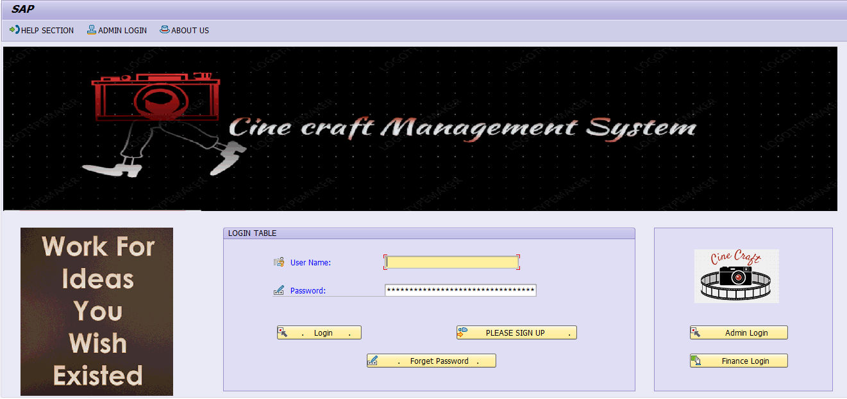

This is the first screen of our cine craft management system.

* If the user is already registered he/she may login directly, else go for signup screen.
* If the user forgets the password .He she can use the forget password button.
* Authorized admin person can do admin login to view help sections and update tables.
* Authorized finance person can do finance login and view payment requests and release payment requests.

Login Screen: Login if Existing User

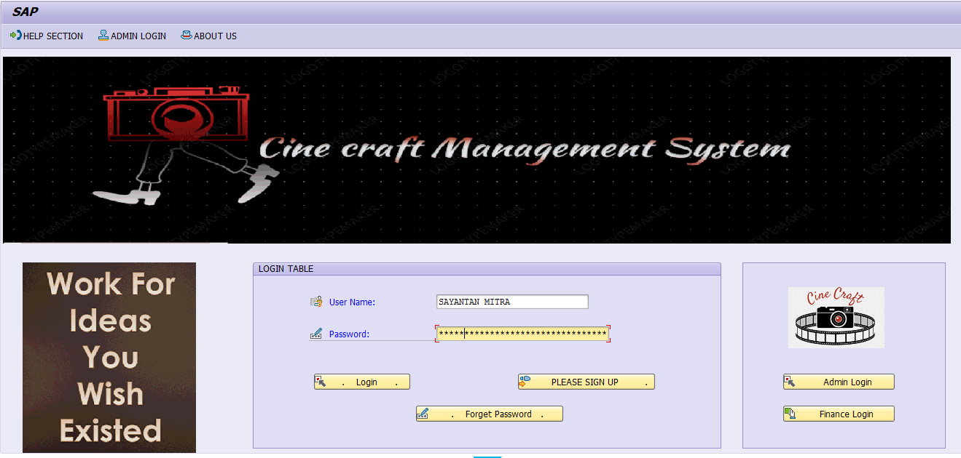

Login Screen: Forgot password->Reset Password

Login Screen: Validation for new and old passwords do not match.

* Enter user ID to change passwords.

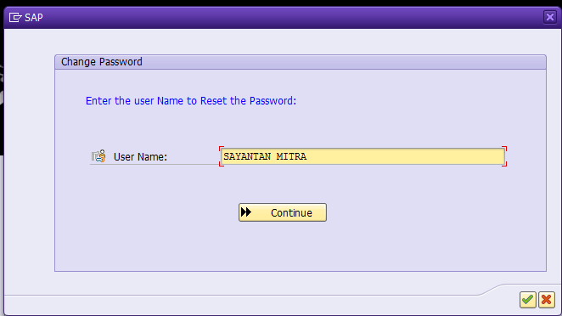

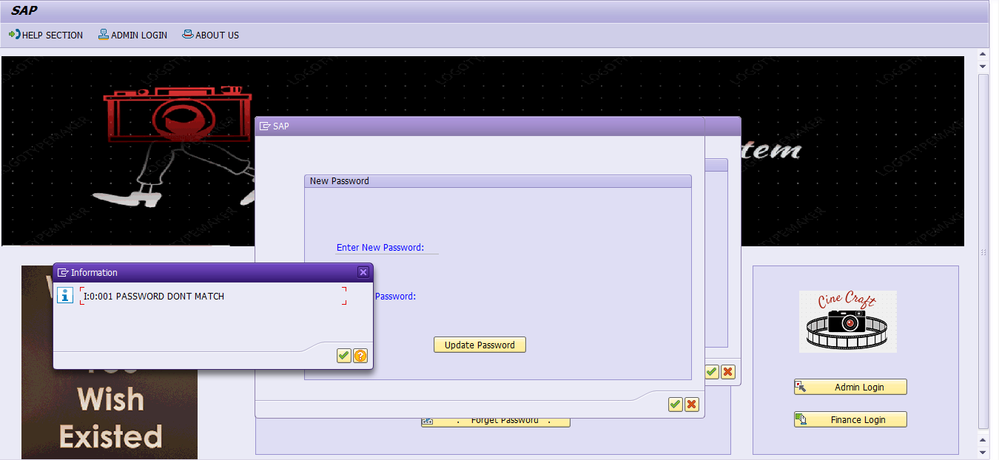

* Password do not match message for wrong password

Login Screen: Admin Login

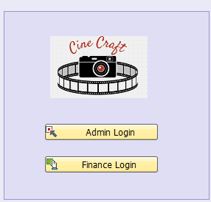

1. **Screen 2: Admin Section**

* Updates the table data
* View complaints

Admin Login Screen

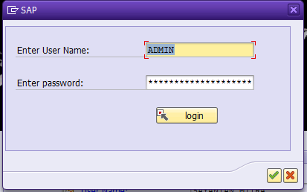

Admin Screen: View Complains

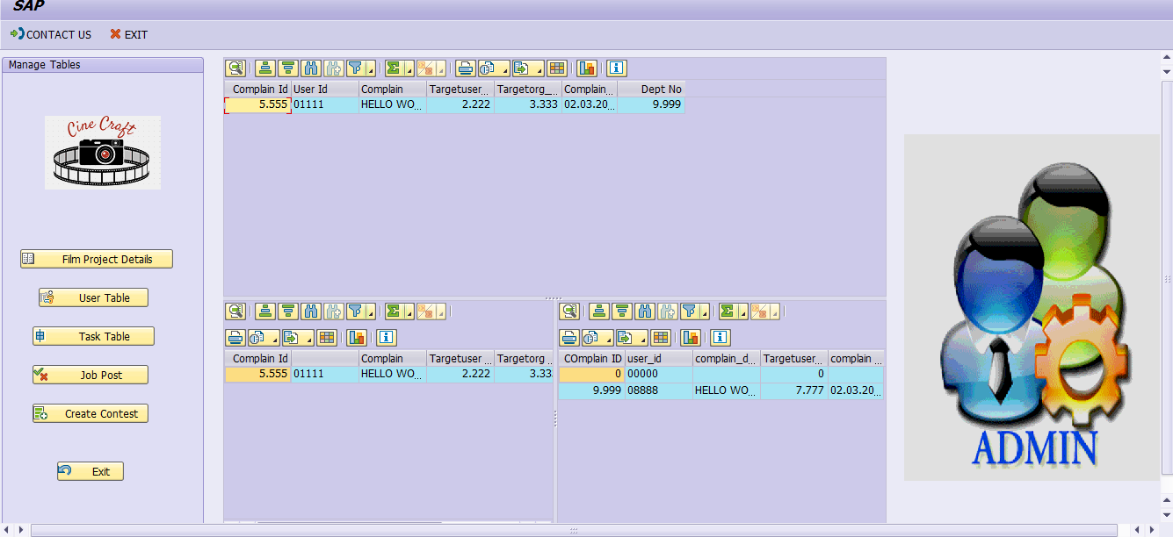

Admin has rights to update all the tables and also to view complains coming from women section. Admin will edit the job post and edit the tables as and when needed.

Finance Login



Finance Screen

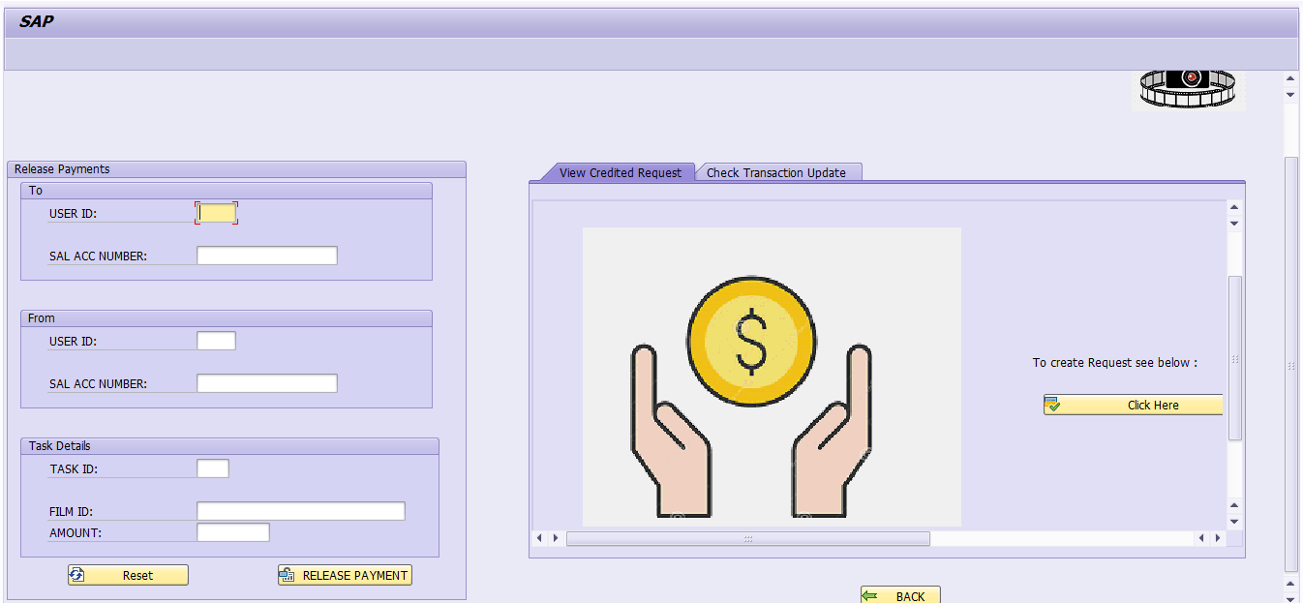

Finance Screen: View Create Request

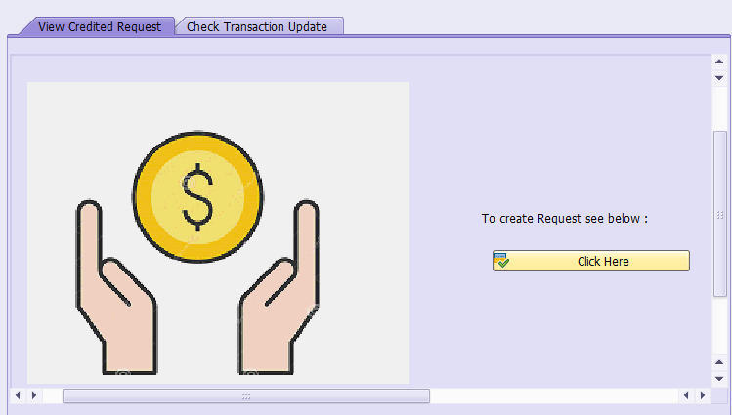

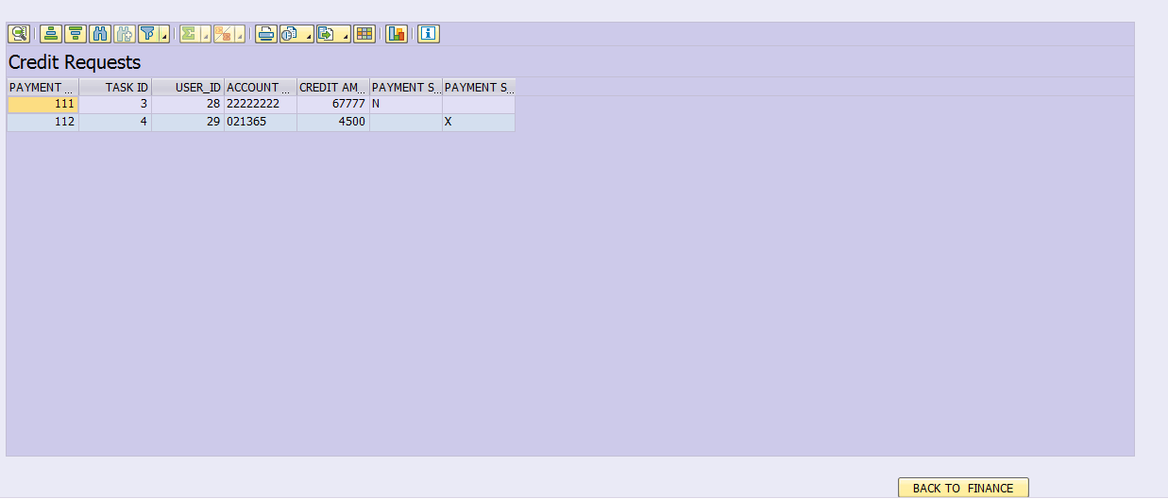

1. **Screen 3: Finance Section**

* View Payment
* View payment request release payment request

Finance Screen: View Request and Insert into

Transaction Table to Release Payment.

transaction to

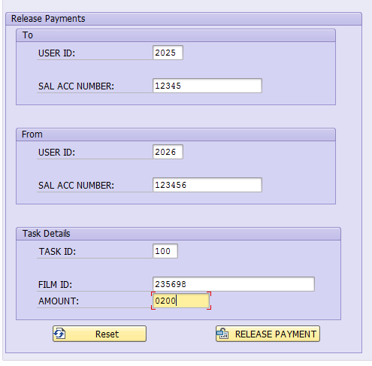

Finance Screen: View Transaction

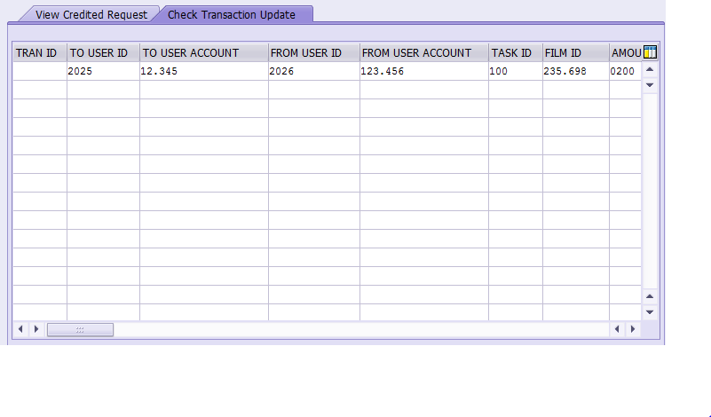

**4.Screen 2 : Signup**

* Insert Master User Data.
* Radio Buttons
* Screen Validation

Sign Up Screen

Enter the details for sign UP.

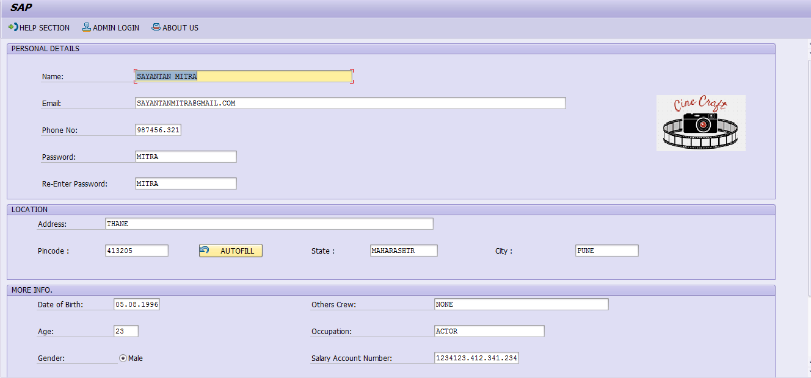

Sign Up Screen: View SignUp Validation

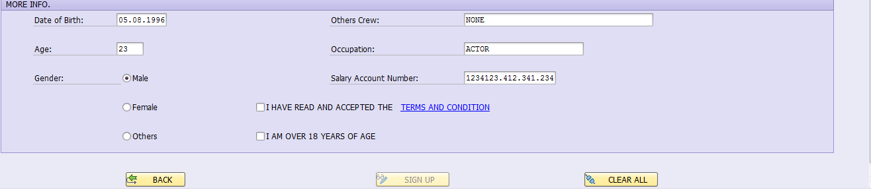

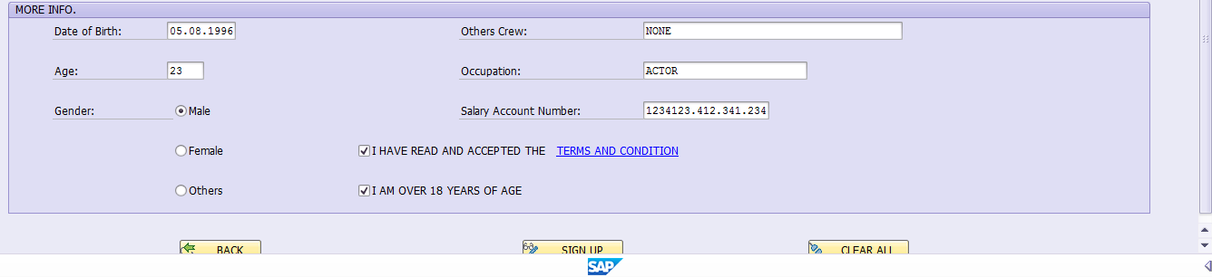

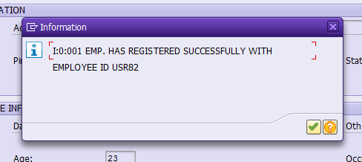

Automatically generated user ID.

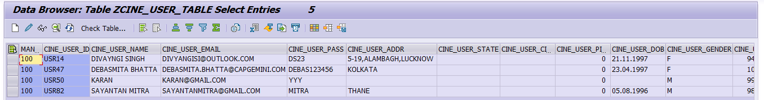

**5.Screen 3 : Home Page**

* Select From 3 modules .
* Create new Movie Project.
* Search for Job.
* Search for Institutes.

Home Screen

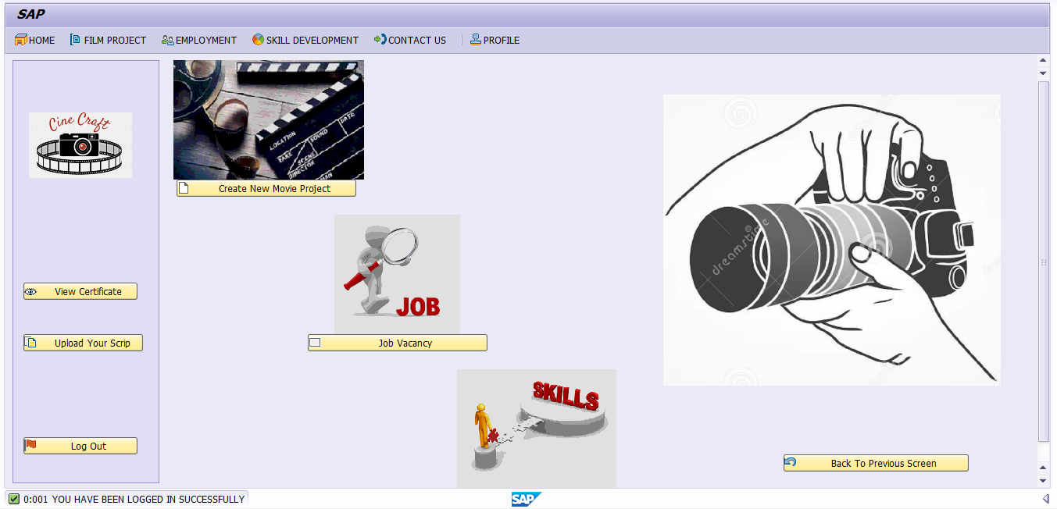

After login in user will land into this page. This page mainly consists of three modules.

1. Create new movie project
2. Job vacancy
3. Skill development

There is also a section to view certificate for some course undertaken.

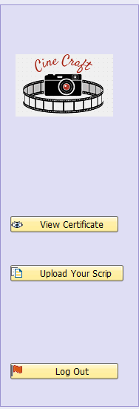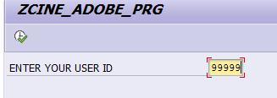

Adobe Form

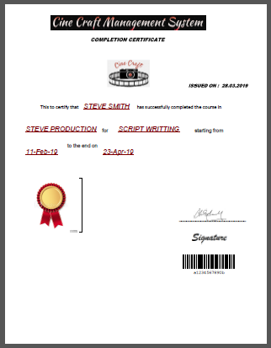

**5 .Screen 4: Create New Film Project**

* Enter details of new film.
* Insert display and continue to create task

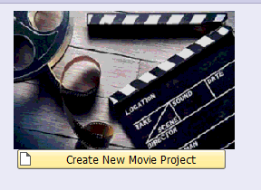

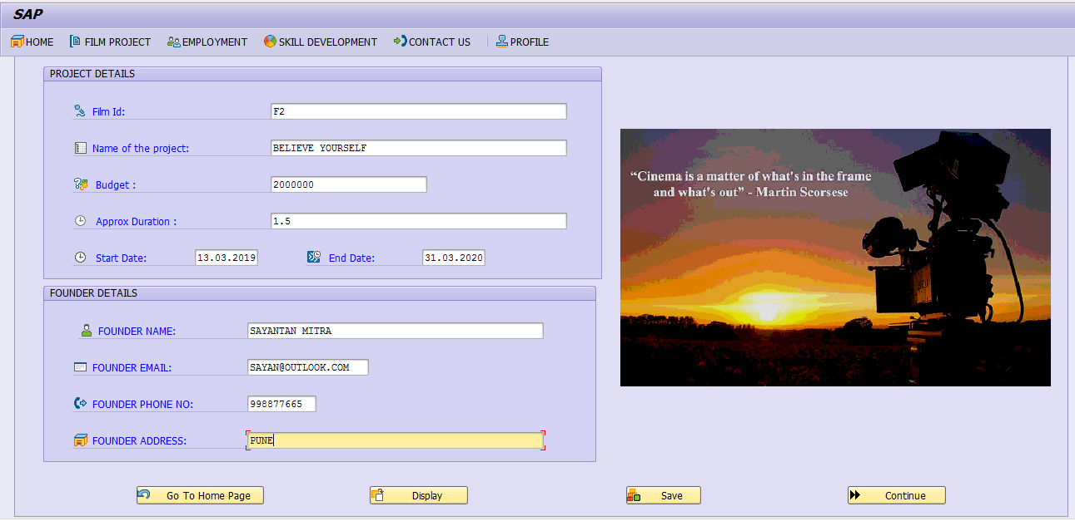

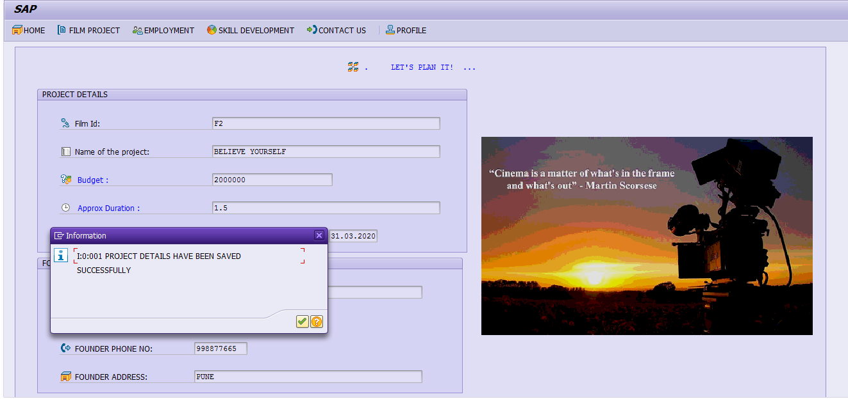

1. **Screen 5 : Task Creation/Crew Selection/Task Validation**

* Insert Created Task.
* Screen Validation
* **Crew Selection**: Based on Film ID -> Display task in table -> Based on Task number fetch department -> Based on department fetch user and display ->select user->view profile.
* **Or insert data in job table to diplay**
* **Task Validation:** Display the list of tasks created last and select and click on push button to update status
* Create task for your movie

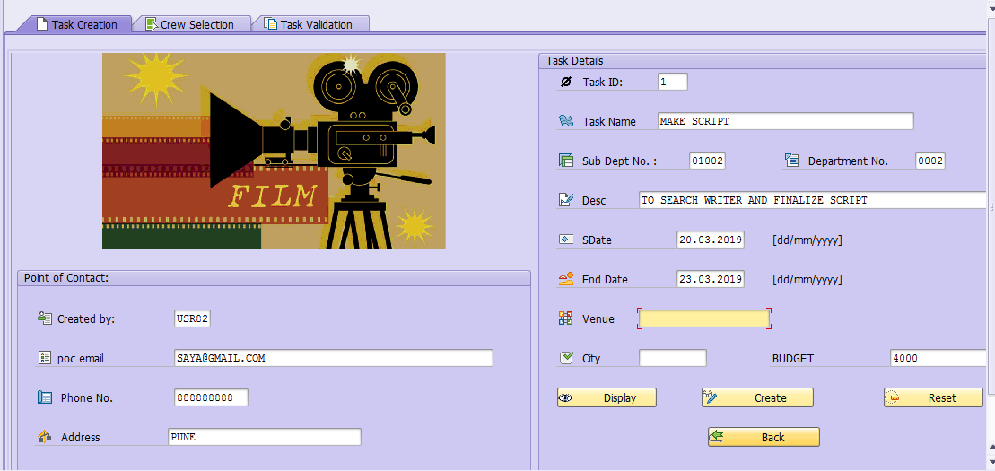

* Task Created

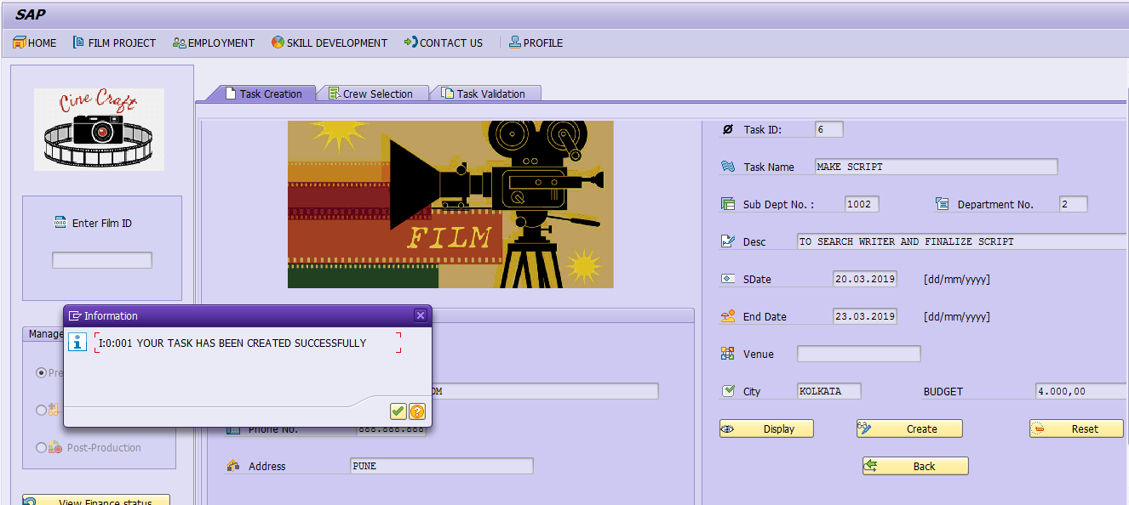

* Now select crew members for your task

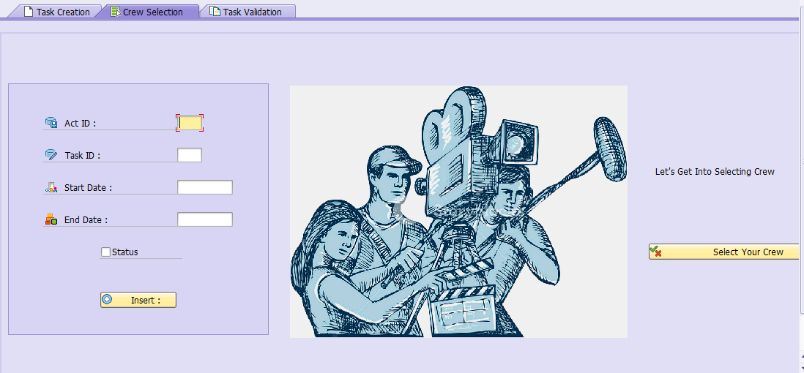

* Now user can go to select your crew button and then on the basis of film id view tasks and then for tasks display users of the associated department.

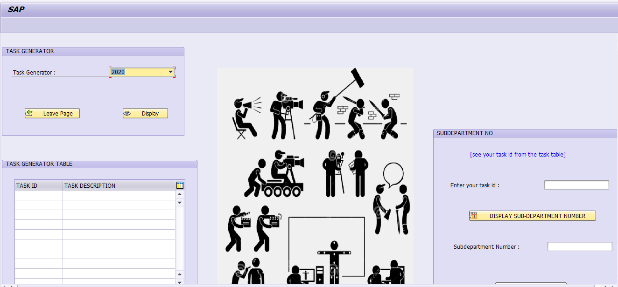

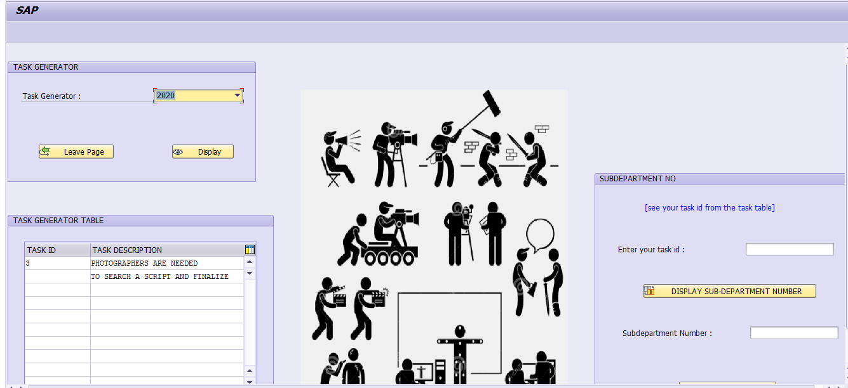

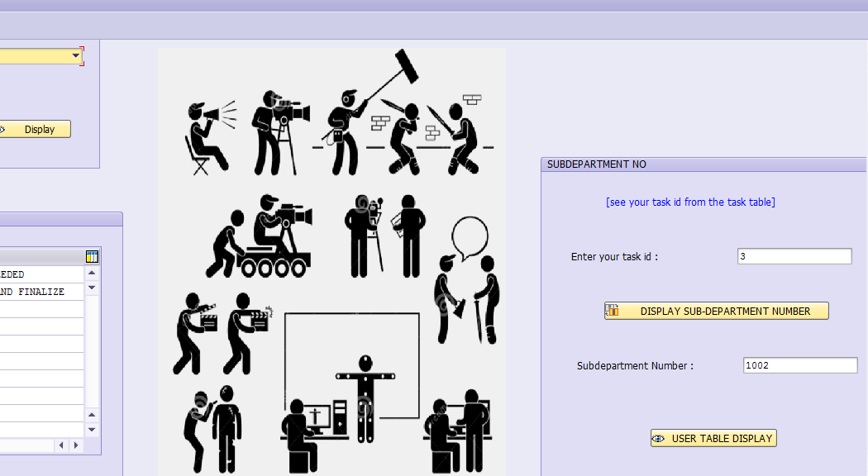

* User can view profiles of the people of selected department.

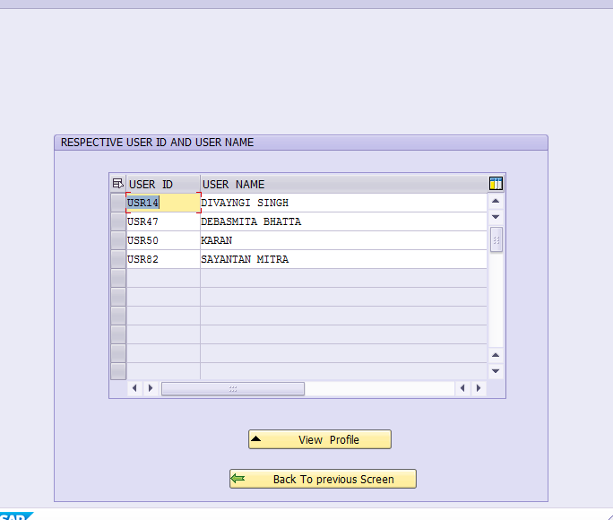

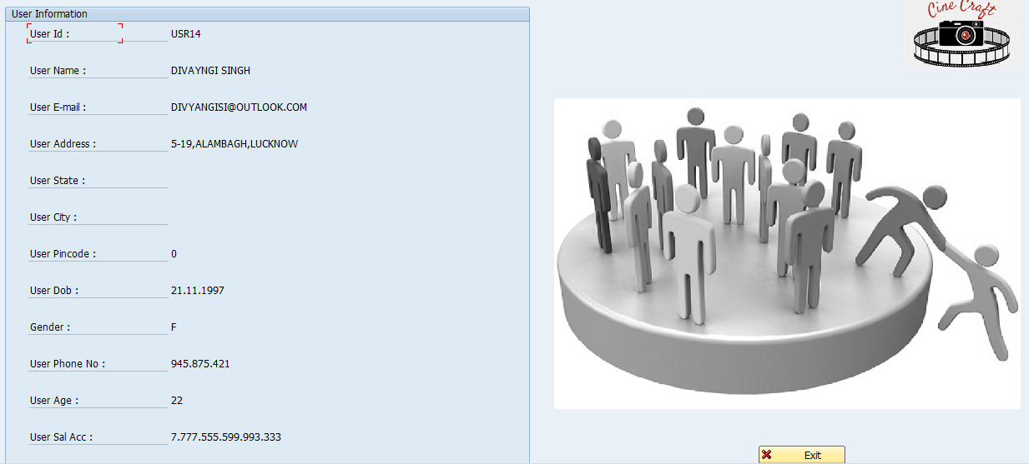

* Here the user can release the payment of user who have completed their tasks.

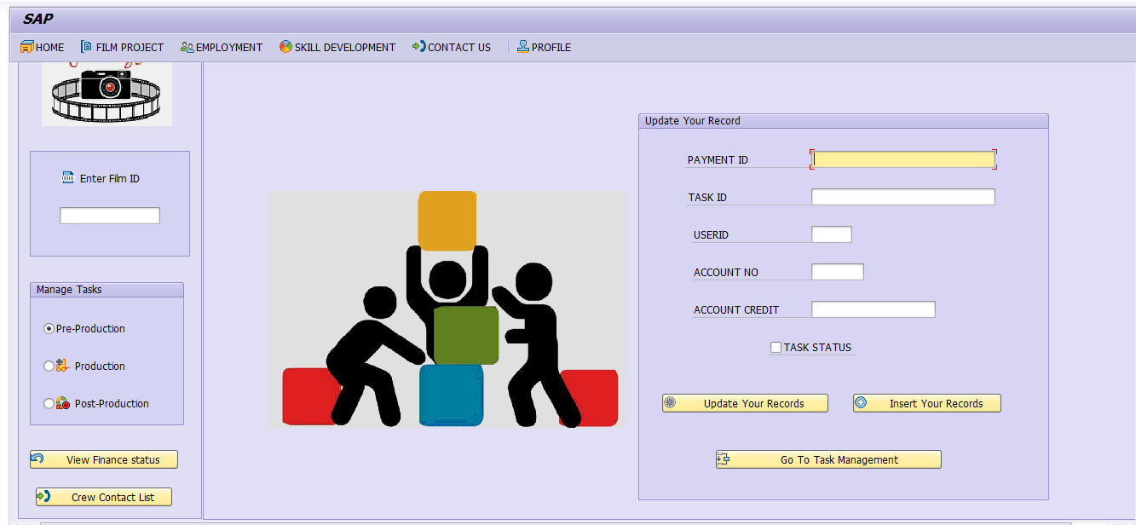

* Here the user can view the tasks he created and associated crew members task status in hierarchical view.

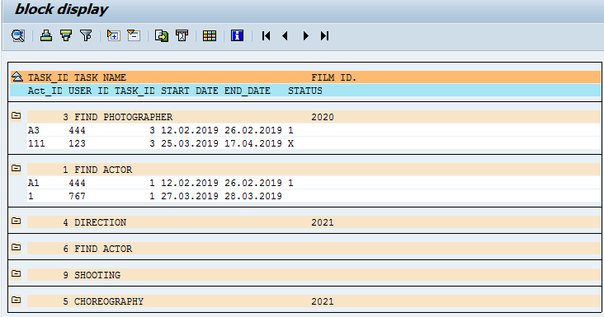

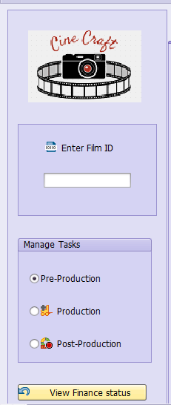 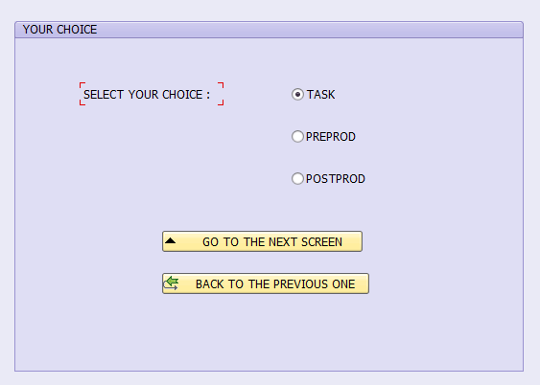

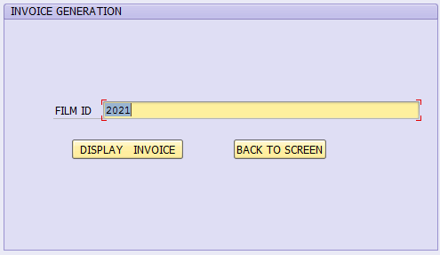

SMARTFORm

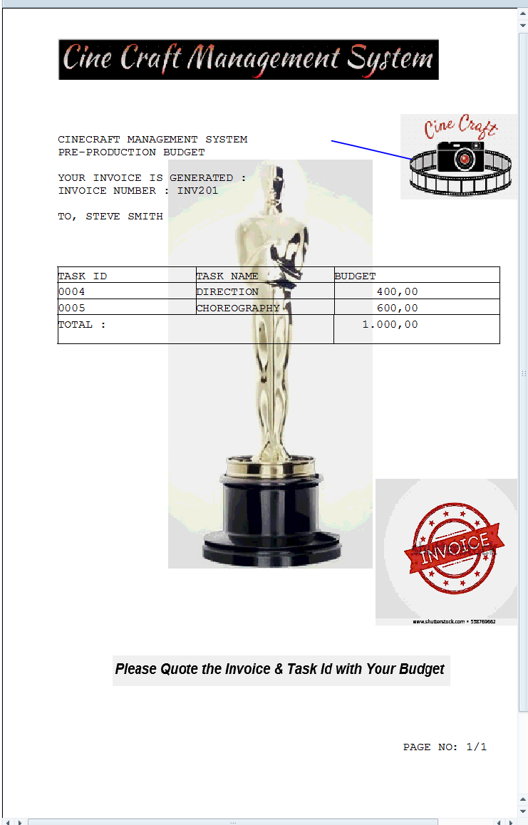

**7.Screen 6: Search for Job**

* The created job for particular task will be displayed here.
* Apply for job.
* Activity logs will be stored in a table.
* The job creator can display them on screen 4 and select.



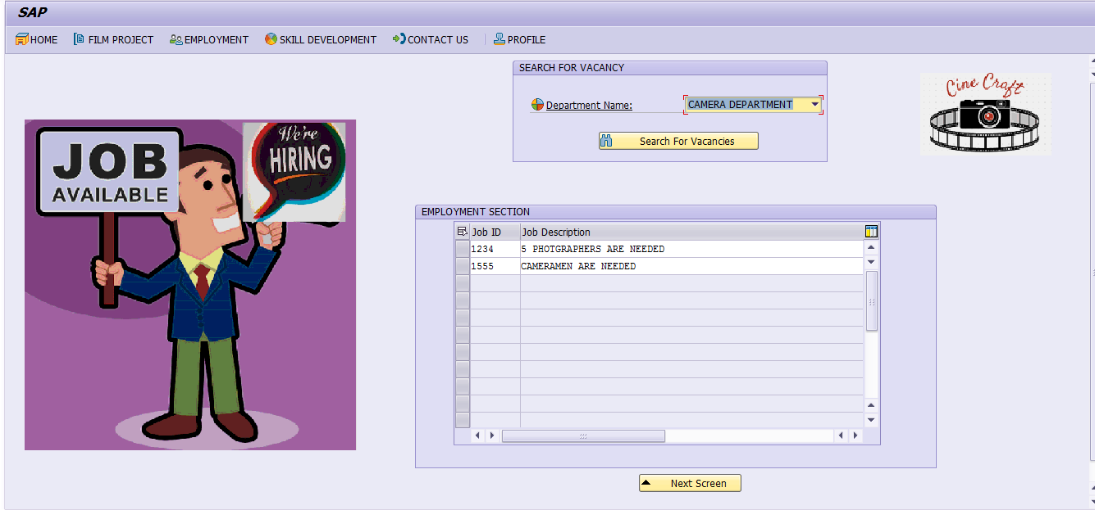

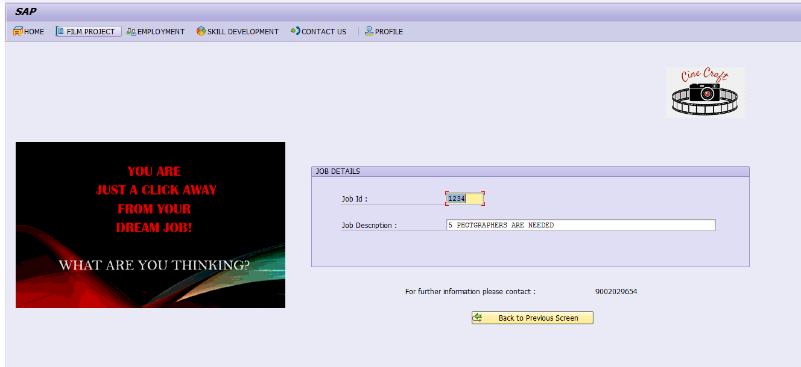



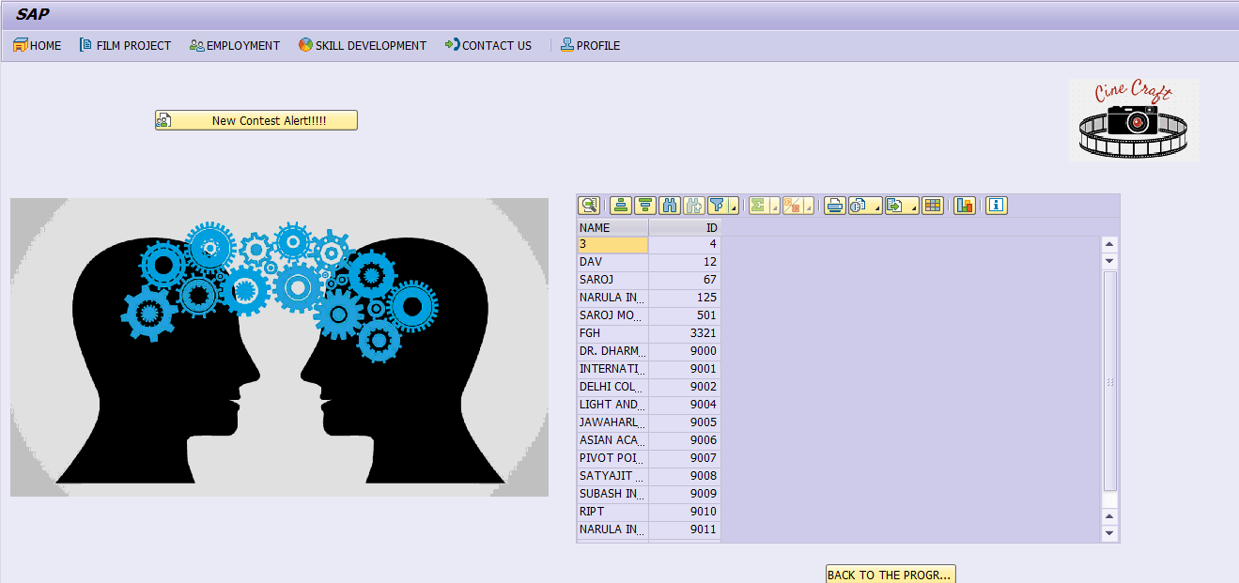

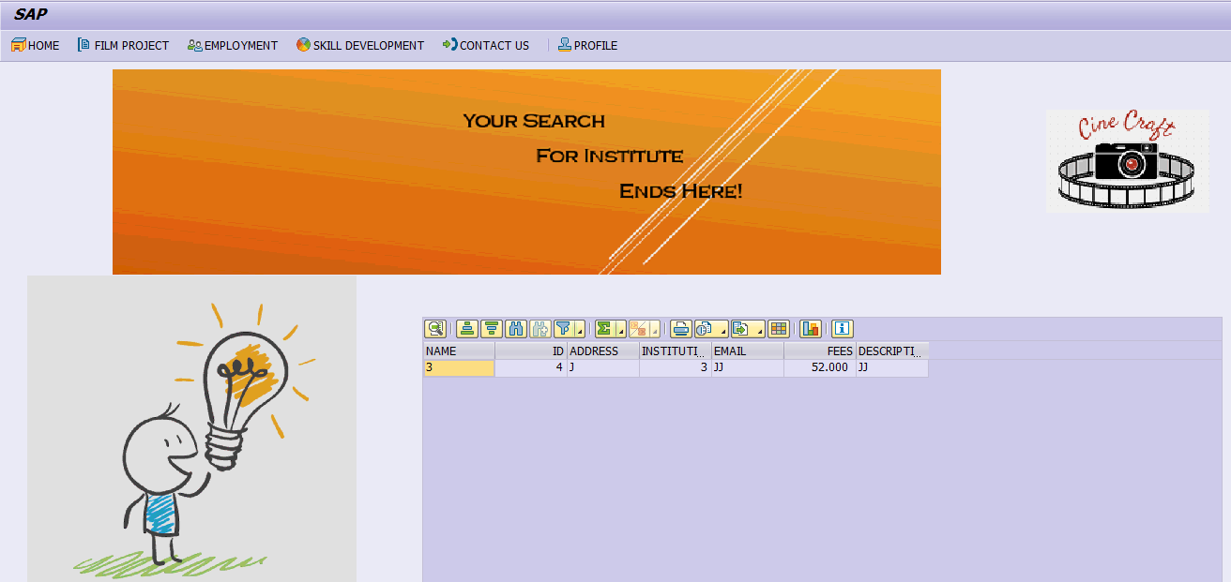

1. **Screen 7:**

* Search Institutes for enrolling in a course for skill development
* Search for contests.

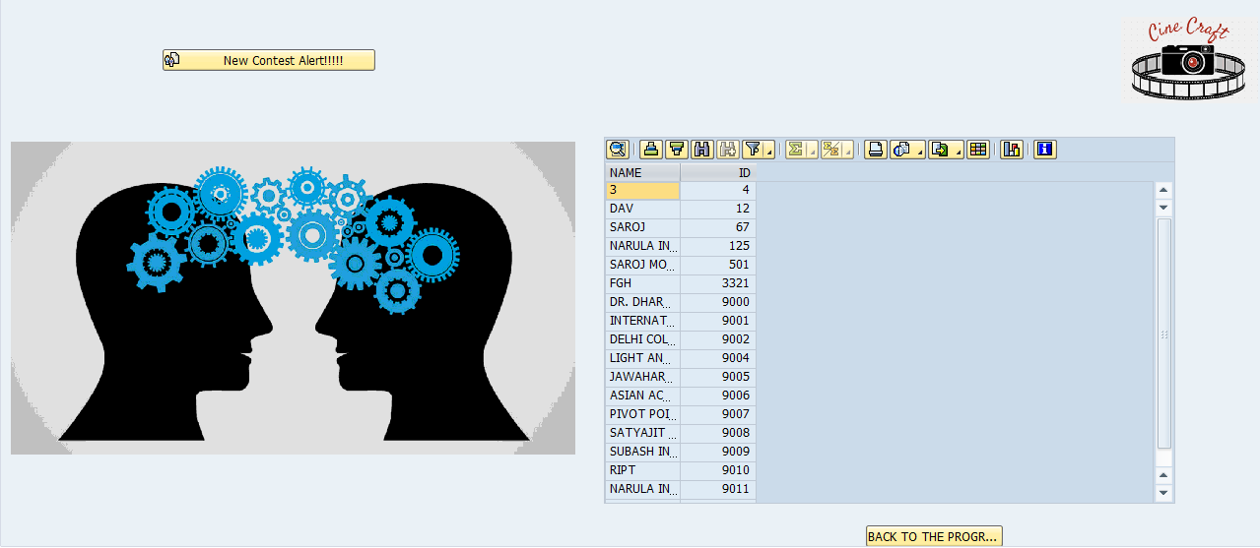

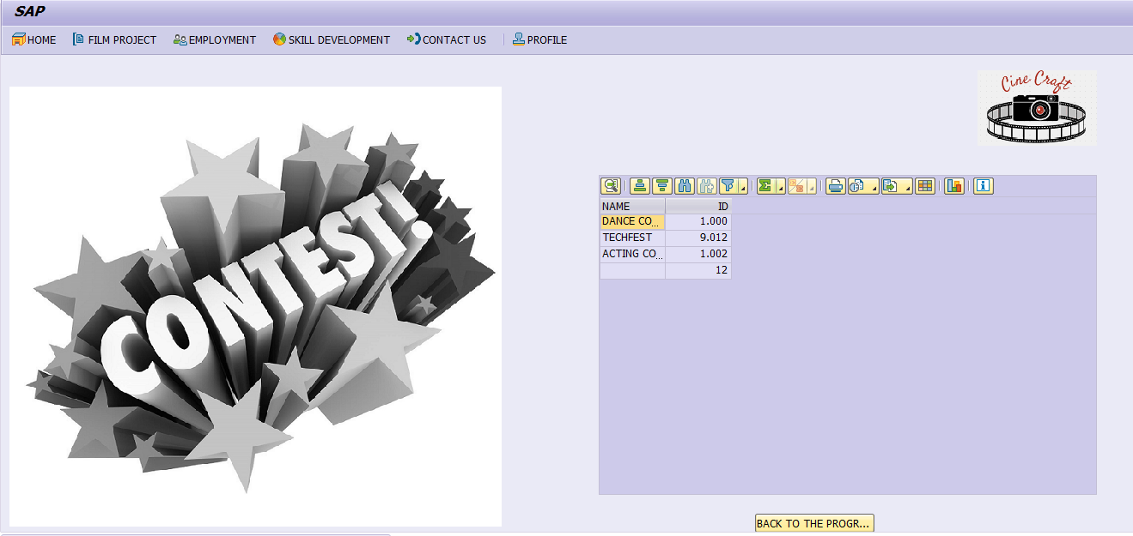

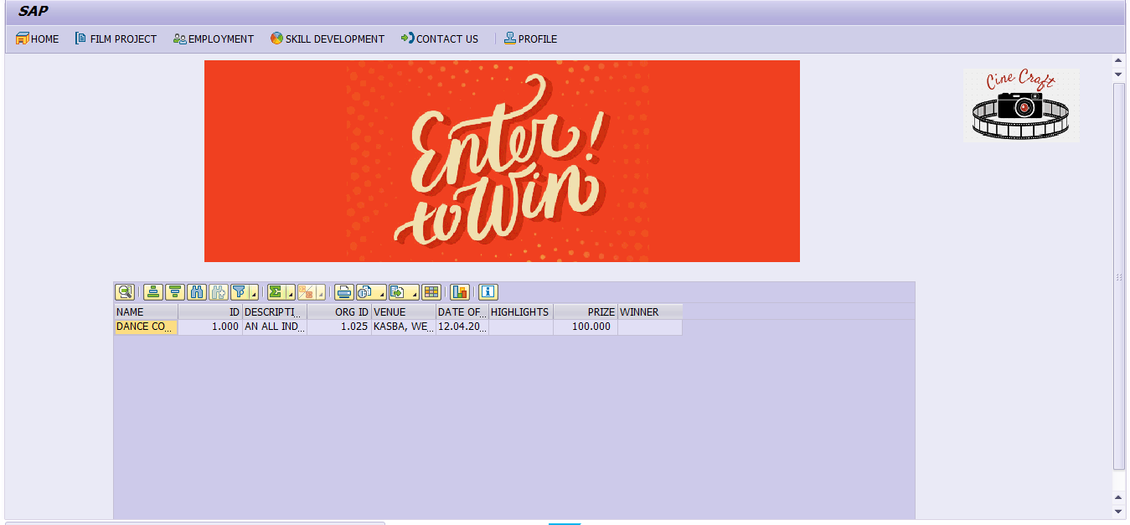

**9.Screen 8: Help Section**

* Complaints inserted to complain table
* Women problems in women complain table
* All these can be viewed by admin to take actions.

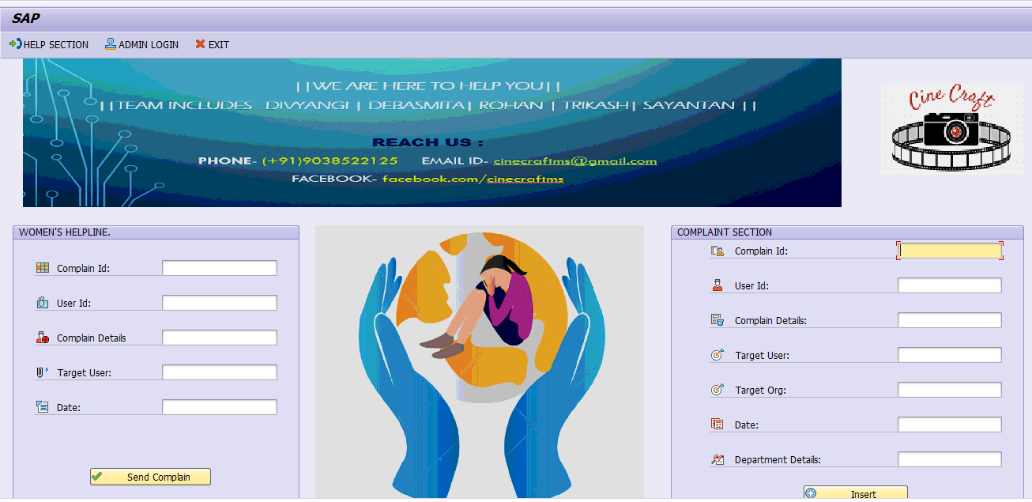

**9.BDC FOR INSTITUTE TABLE**

* Complaints inserted to complain table
* Women problems in women complain table
* All these can be viewed by admin to take actions.

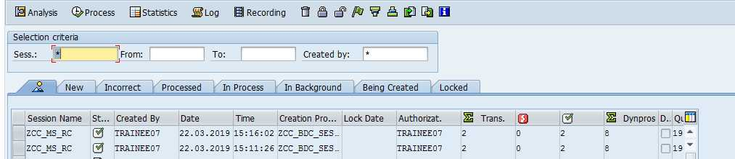

********************************* THANK YOU! *******************************************